**“MEDICAL EXPERT SYSTEM FOR DIAGNOSIS OF VARIOUS DISEASES**

**USING KNOWLEDGE RULE BASED SYSTEM”**

**PROJECT REPORT**

Submitted for the course: CSE4020 Machine Learning

By

# Rhythm Sahu 16BCB0086

**David Shahji George 16BCB0045**



Slot: F2

Name of faculty:Prof. Vijayasherly V

(SCHOOL OF COMPUTER SCIENCE AND ENGINEERING)

***Abstract***

Diagnosing disease on time is the first step in treating the diseases. In our country the ratio of doctor to patient is 1 per roughly 1000 patients (1:961 to be exact). Due to this striking imbalance in ratio, the demand for doctors is very high and hence the cost per visits to the doctor is also high. Due to this reason, people often wait until the severity of the symptoms increases. Also, in some cases patients self-medicate

themselves, which is also dangerous. Our task is to develop a ‘Medical Expert System (MES)’ using Artificial Intelligence. The aim of this MES is to try to diagnose the disease.

MES will be asking the user if he is experiencing any symptoms one by one and try to narrow it down to possible disease(s). MES will be built up of medical Knowledge Base. The information given to the MES will be similar to the information which the doctor knows in treating the diseases i.e. Knowledge Based System (KBS). The way doctor approaches the patient to diagnose the disease; our MES will be chatting with the user to get appropriate information on the symptoms. Using programs and production rules, it will narrow it down to possible disease(s).

***Keywords****:* Machine Learning, Medical System, Production Rules, Disease and Symptoms, Artificial Neural Networks.

## Introduction

In this modern age, computer-based methods are massively used to improve the quality of medical services. Artificial Intelligence (AI) is the area of computer science focusing on creating machines that can engage on behaviours that humans consider intelligent.

One of the most important areas of Artificial Intelligence (AI) is an Expert system. The proposed system for dealing with the problem of diagnosis of diseases and treatment is an expert system. Expert Systems (ES) are widely used in many areas and they have many applications. One of the most important field area of expert system is medicine and its use in detection, diagnosing symptoms and treatment diseases.

The user can interact with a computer to solve a certain problem by expert system. This is because the expert system can store heuristic knowledge. These programming tools facilitate human knowledge or expertise for medical therapy.

This helps the medical expert (doctor) for diagnosis of a disease in a patient correctly. There are a lot of diseases that have a lot of common symptoms. Some of them have similar symptoms that make very difficult even for a specialist to put a right diagnosis can do that. Many fatal diseases like Tuberculosis, AIDS can be diagnosed based on the symptoms that the person is suffering from and after thorough investigation. Many diseases can lead to death or further complications. However, if detected early enough, the disease can be cured and relief can be provided.

### Expert Systems:

An expert system (ES) known as knowledge based system, is a computer program that uses knowledge and inference procedures to solve problems that are ordinarily solved through human expertise. The main components of an ES are:

1. Knowledge base,

It contains information of the diseases, characterised as if then production rules. It is analogues to human memory. Consider the example for a patient having malaria. It will be stored in KB in the form as shown in the image below where 1 represents the symptom present for a particular disease and 0 represents the absence of a symptom for a particular disease.

The KB is stored in a CSV format. Selection of Symptoms are based upon the frequency of which they occur in multiple diseases.

b) Classification Model:

The job of this particular module is to match the inputs from the user to existing rules, stored in the knowledge base system. This is analogues to the doctor analysing the symptoms and matching them with their knowledge and experience gained during their career. The main advantage of this system is that while a doctor can relate only to his past experiences, which are limited , MES contains the knowledge of many doctors and their experiences which allows it to make a much better prediction.

c) User-Interface.

There are many applications of expert systems such as diagnosis, design, planning, financial decision making etc. Most applications of expert systems in medicine involve predicting, diagnosing and treating a particular disease. Now expert system has many other roles in clinical care such as disease prevention, therapy, rehabilitation of the patient after therapy etc. In medicine, expert systems are used to train the medical students on various medical tasks. In certain situations, where either the case is quite complex or there is no medical experts readily available for patients medical expert systems are useful. From the very beginning the main obstacle of using expert systems in medicine has been the accuracy of such systems. The development of an expert system requires medical data of specialized doctor. This data is collected in two phases.

### Neural Networks:

Artificial Neural Networkhelps doctors to understand complex clinical data across a large number of medical applications. In medical application, the task is on the basis of the measured features to allocate the patient to one of a small set of classes. An artificial neural network is a computational model that tries to report for the parallel nature of the individual brain. An artificial neural network is an arrangement of extremely interconnecting processing elements operating in parallel. These elements are stirred by biological nervous systems. As in environment, the connections between basics largely find out the network function. A subgroup of processing part is called a layer in the network. The primary layer is the input layer and the final layer is the output layer. Between the input and output layer, there may be extra layers, called hidden layers.

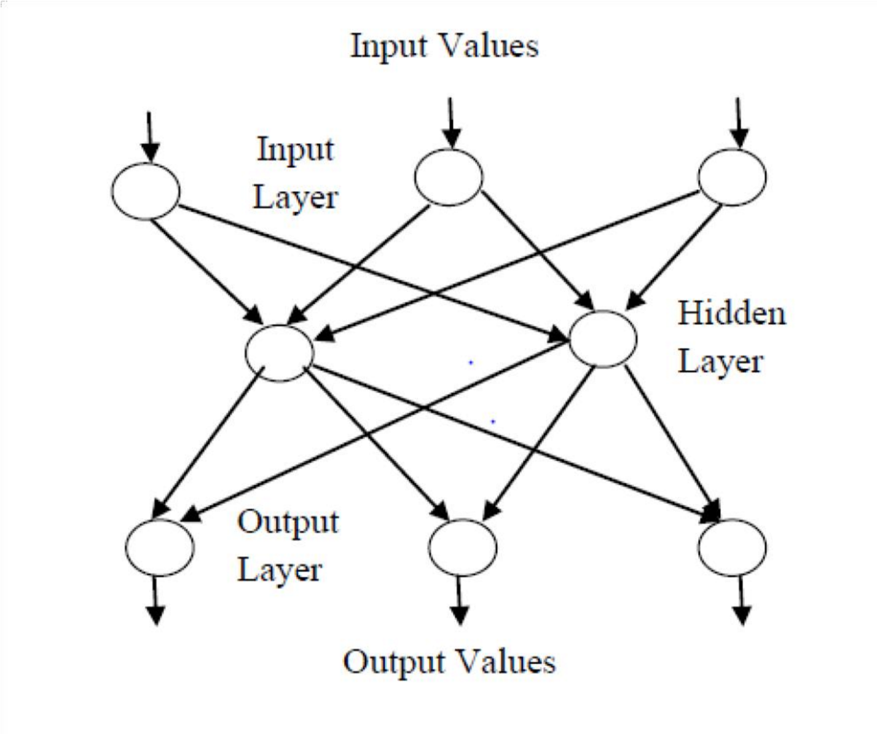

**Fig.1 A typical Neural Network**

## Related Works

The Medical diagnostic Systems have undergone many changes and are using new techniques to generate better results. This section presents a comparative analysis of various existing studies in the following table:

|  |  |  |  |  |
| --- | --- | --- | --- | --- |
| **Reference** | **Disease Diagnosed** | **Technique Used** | **Input** | **Remarks** |
| Mohammed Abbas  Kadhim, M. Afshar  Alam, Harleen Kaur | Back Pain Disease | Fuzzy Expert  System | Body mass index, age, gender and clinical observation symptoms | This system is tested  using  clinical data that corresponds to 20 patients with different back pain diseases and 90% accuracy is achieved. |

|  |  |  |  |  |
| --- | --- | --- | --- | --- |
| **Reference** | **Disease**  **Diagnosed** | **Technique Used** | **Input** | **Remarks** |
| Qeethara Kadhim AI- Shayea | Acute Nephritis  Disease | Artificial Neural  Network | Disease symptoms | 99% accuracy is achieved in diagnosis of Acute Nephritis  Disease. |
|  |  |  |
|  | Heart Disease |  | Data is on Cardiac single proton emission computed tomography images | 95% accuracy is achieved in diagnosis of heart disease using feed forward back propagation network. |
| Eugene Roventa,  George Rosu | Kidney Disease | Rule based Expert  System | Disease symptoms | This system contains knowledge of 27 kidney diseases but no experimental results are found. |
| K.Abdelhamied,  S.Hafez,  W.Abdalla,  H.Hiekal, A.Adel | Major and Minor  Diseases | Rule based Expert  System | Disease symptoms | The system contains knowledge of 300 major and minor diseases. It is being evaluated in 10 outpatient clinics but no experimental results are given. |
| Solomon Gebremariam | Diabetes Disease | Rule based Expert  System | Disease Symptoms, Lab test results, Age, Family history, obesity, Ketone | This system provides advice to physicians and patients to facilitate the diagnosis and treatment of diabetes the Performance of the system is 84.2%. |
| Sandeep  Pachpande,  Ramesh Mahadik | Pulmonary disorders | Rule based Expert  System | Disease Symptoms | This expert system shows that construction of expert system is not a single pass fashion. It is an incremental approach. No experimental results of this expert system are found. |
| S.Ali, P. Chia,  K Ong | Chest Pain | Knowledge Based  System | Data obtained from Laboratory  Examinations, Chest X- Ray images, Ultrasound Video, Narrative texts describing the patient's condition | This expert system delivers appropriate clinical guidelines and is finalized for pilot trial at the accidents and emergency department of the national university hospital. No experimental results of this expert system are found. |
| John G.  Holmen,  Anthony H. Walff | Oliguria occurring on the Intensive Care Unit | Knowledge Based  System | Central Venous  Pressure | This system gives advice about oliguria occurring on intensive care unit and no experimental results are shown. |

|  |  |  |  |  |
| --- | --- | --- | --- | --- |
| **Reference** | **Disease**  **Diagnosed** | **Technique Used** | **Input** | **Remarks** |
| Freasier, R.E, Cios, K.J, Goodenday, L.S | Predominant  Coronary Arterial  Stenosis | Knowledge  Based  System | Data obtained from preprocessed scintigraphic myocardial perfusion images of the left ventricle taken in three views | This system determines the site of the predominant stenosis. With the current set of production ru les, the system properly recognized the site of coronary artery stenosis in over 90% of the patients presented. |
| Jimmy Singla | Lung Diseases | Rule based Expert System | Disease symptoms | This expert system contains knowledge of 32 lung diseases and the system has70% accuracy. |
| Samy S. Abu Naser, Abu Zaiter A. Ola | Eye Diseases | Knowledge  Based  System | Disease symptoms | The proposed system can help doctors and patients in providing decision support system, interactive training tool and expert advice. A number of doctors and patients tested the system and gave a positive feedback but no parameters are calculated for this expert system. |
| Ahmad A, Al-Hajji | Neurological Disorders | Rule based Expert  System | Disease symptoms | This expert system helps the patients to get the required advice about the different disorders attack to them due to their nervous system disorders. Since No parameters are retrieved. |
| Obi J.C, Imianvan A.A | Leukemia | Neuro–Fuzzy Expert System | Disease symptoms | This expert system tells the patient his current condition as regards leukemia. No parameters are retrieved for this expert system. |

***Proposed Method and Algorithms***

1. Knowledge Base:

It contains information of the diseases, characterised as if then production rules. It is analogues to human memory. Consider the example for a patient having malaria. It will be stored in KB in the form as shown below:

Disease (patient, malaria):-

Symptom (patient, high_fever),

Symptom (patient, chills),

Symptom (patient, watery_stools),

Symptom (patient, severe_headache),

Symptom (patient, muscle_cramps)

1. Diagnosis Engine:

The most important module of MES. Its task is to bring out the reasoning by connecting the rules with facts and deducing new facts. Further when all or most of the symptoms match with a particular disease or similar diseases, it will prompt the user.

1. Interface:

We will be using the tkinter library in Python to implement the Graphical User Interface.

## Input and Output:

* The MES will be provided with a series of inputs, one at a time
* For every input, the diagnosis engine will try to match it with different diseases
* It will stop asking for further inputs when it narrows it down to a single disease or a set of closely related diseases
* Output shall be the name of disease(s) which the user is probably facing.

***Algorithm:***

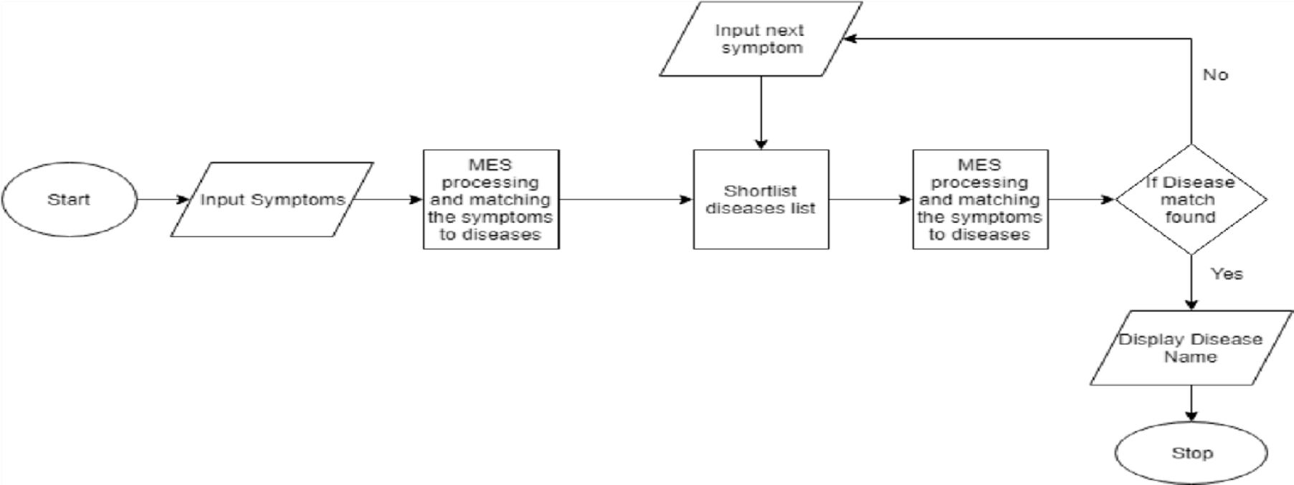

**Fig.2 Algorithm Flowchart**

The system will ask for some symptom(s), and then it will narrow down to the diseases having the common symptom(s). Then it will go up to the above step given in the figure [2]

In the figure [2]. If the system has a positive response to a symptom, it goes on with the symptoms of that disease. If the system has a negative response for the symptom of that disease, it jumps to the first symptom of the next disease. It goes on till the disease is diagnosed.

***Result and Discussion***

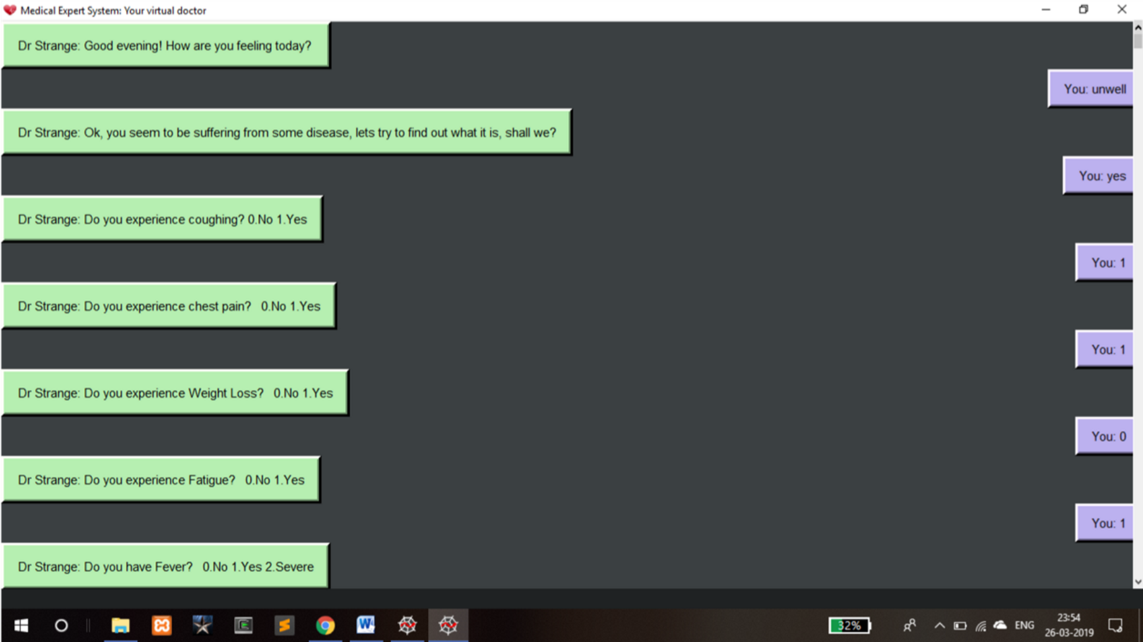

**Figure1. Chat-bot Interface**

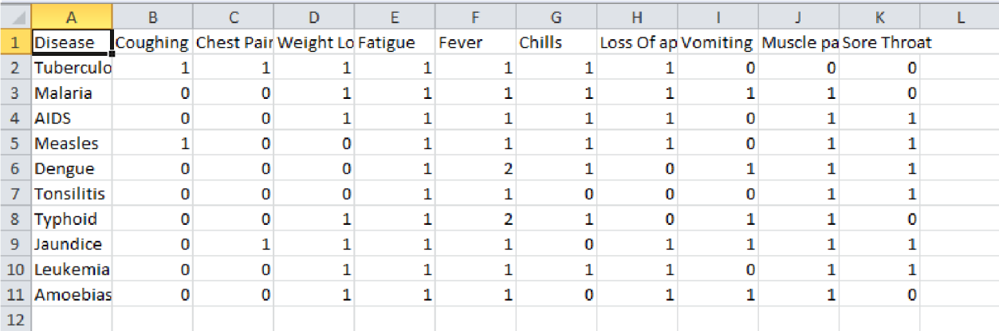

**Figure2. Disease and their symptoms**

The chat-bot interface queries about the symptoms of the patient by asking if the user is suffering from a certain symptom or not. The user answers in a YES/NO format by pressing 1 or 0. After taking all the symptoms that are shown the patient the program determines which disease the patient is suffering from by matching it with the dataset of diseases and their symptoms shown in Figure2. It then predicts the disease after the analysis.

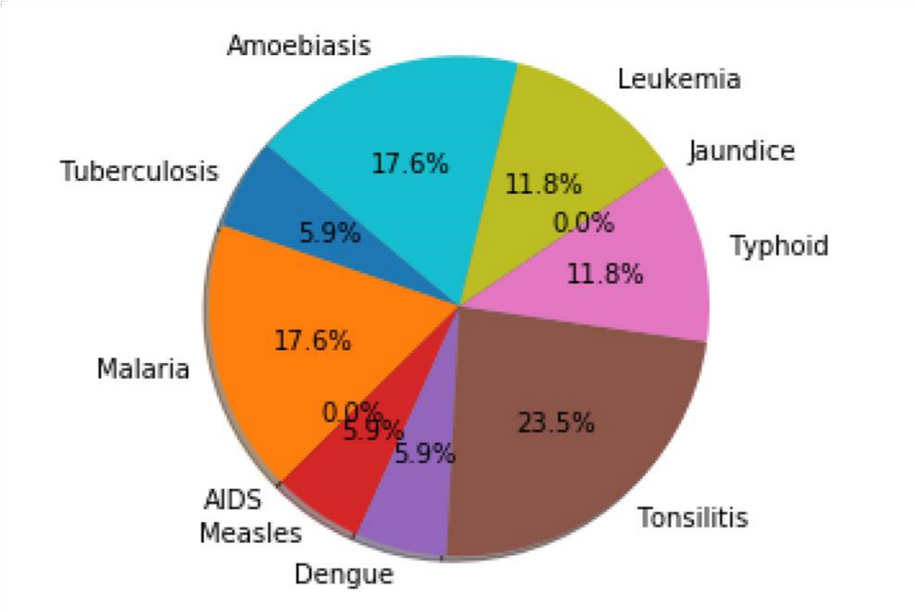

**Figure3. Pie Chart**

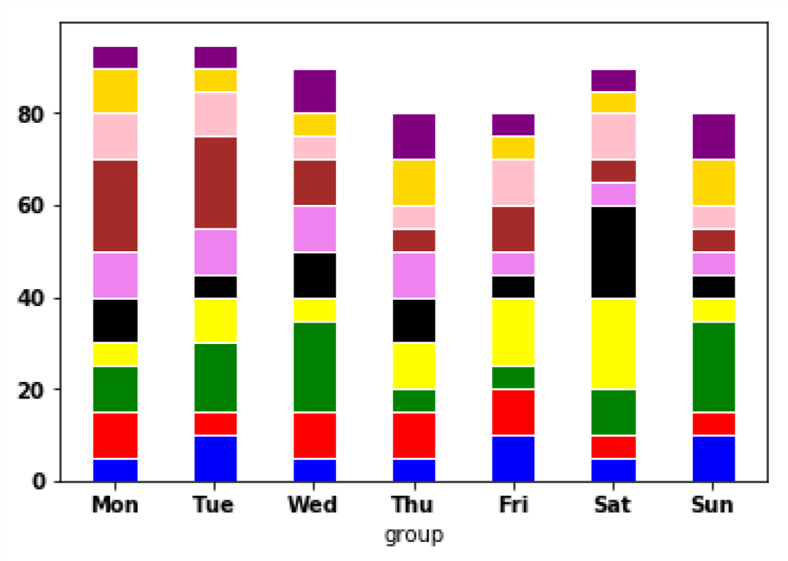

**Figure4. Bar Graph**

After the disease prediction for a particular date is over the Final Count is saved in a csv file. The Figure3 and Figure4 successfully depict the count of diseases for a day and for the entire week respectively.

***Conclusion and Future Works***

In general we successfully built a Medical Expert System by using Neural Networks that can diagnose the disease that the patient is suffering by asking the user for symptoms and then comparing it with existing dataset. Unlike conventional expert systems, this can be achieved with minimum of outside intervention, so that over time the network gradually takes over the task of the human expert. The neural networks behave much better with erroneous or incomplete input than a shell-based expert system because it uses all the knowledge encompassed in its connections. In fact, neural networks-based expert systems can be used to help suggest certainty factors to humans. A neural network-based expert system will increase the knowledge represented in its connections over time by learning from more examples.

The dataset that we use consists of only 10 diseases with symptoms. We can use this expert system tool to predict the disease on a larger scale in future. Also the interface asks the user only predefined symptoms thereby not allowing the user to add any symptom of his own. What if the patient is suffering from a symptom that is not in the database? We will try to answer these questions and come up with a better solution for these obstacles in the future.

***References***

1. *Expert systems made with neural networks,* *Rafeek M. Kottai and A. Terry Bahill*

*Systems and Industrial Engineering^ University of Arizona, Tucson, AZ 85721, USA*

1. *[1] J.J. Hopfield and D.W, Tank, 'Computing with neural circuits: a model7, Science, 233, 1986, pp. 625 -633.*
2. *M. Caudill, 'Neural networks primer, part IV, AI Expert, 38, 1988, pp. 61 - 66.*
3. *D.E. Rumelhart, G.E. Hinton and R.J. Williams, 'Learning representations by backpropagating errors', Nature, 323, 1986, pp. 533 - 536.*
4. *P.H. Winston, Artificial Intelligence, AddisonWesley, 1977.*
5. *E. Collins, S. Ghosh and C. Scofield, 'Risk Analysis', in DARPA Neural Network Study, 1988, Fairfax VA, Armed Forces Communications and Electronics Association (AFCEA), pp. 429 - 443*